

PROSTA-Check®
ref. 8084

Self-testing device for the detection of prostate specific antigen in whole blood

GENERAL POINTS

In man, the prostate antigen (PSA) is secreted by the prostate. This gland, situated in the abdomen under the bladder, surrounds the initial part of the urethra and plays an important role in the semen. The prostate antigen level gives information about the prostate physiological condition. Thus, levels above the norm may show pathology of the prostate (benign hypertrophy, prostatitis, cancer, etc.). The PSA assay could be performed at least once a year in men over 50 years or having a family history of prostate problems.
In case of prostate problem, early screening allows considerably increasing recovery possibilities.

PRESENTATION

The box contains all the material necessary to perform a test:
- 1 sealed aluminium pouch containing:
n1 test device, 1 plastic pipette, 1 desiccant bag
- 1 dropper bottle containing 1 mL of diluent
- 1 sterile lancet for blood sampling
- 1 instruction leaflet
Only open the protection pouch when you are ready to use the test. The desiccant bag should not be used.

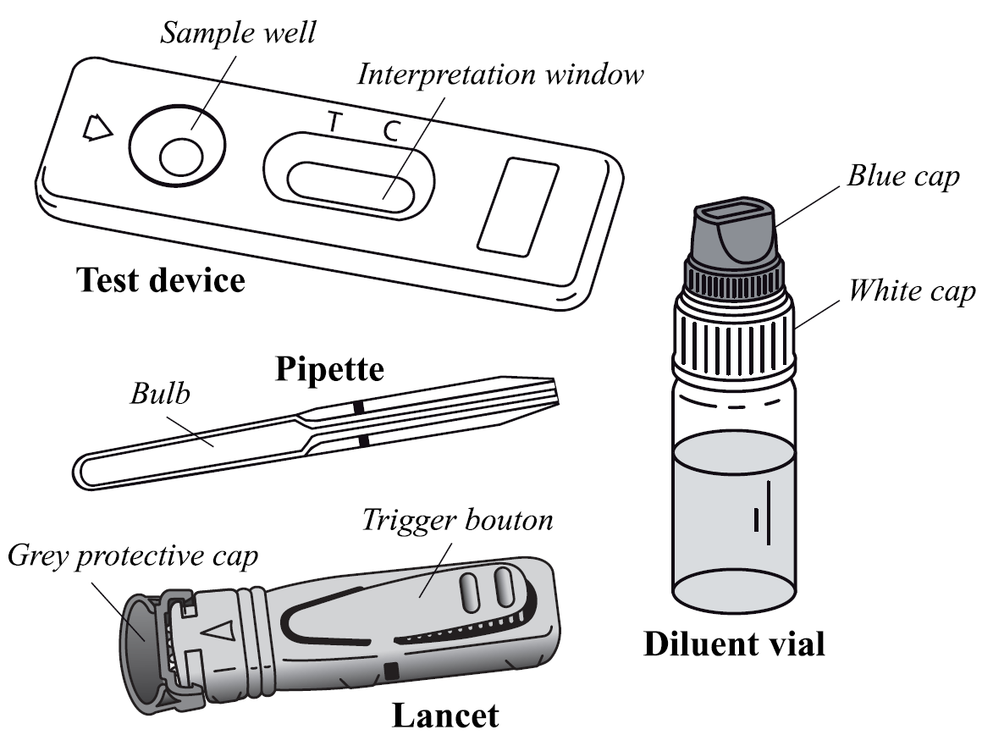

Not provided necessary material: absorbent cotton and alcohol 70 % vol. or alcohol pad.

PRECAUTIONS

1. This test is exclusively intended for in vitro diagnostic. External use only. DO NOT SWALLOW.
2. Carefully read the instructions before performing the test. The test is only interpretable if the instructions are carefully respected. Follow strictly the indicated time, blood and diluent quantities.
3. Store between +4°C and +30°C. Do not freeze.
4. Do not use after the expiry date printed on the label and on the protection pouch or if this pouch is damaged.
5. Do not reuse the PROSTA-Check® test.
6. Keep out of the reach of children.
7. After use, all the components can be discarded in a dustbin.

PROCEDURE

Testing procedure always starts with a good preparation. Place the content of the box on a clean, dry and flat surface (e.g. table). Then the testing follows:

1. Wash your hands thoroughly. Use soap and warm water. Dry your hand with clean towel.

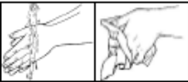

2. Prepare the test device and the pipette. Take them out from the protective pouch (tear at the notch) and place them in the reach of your hands (you will need them later). Discard the desiccant bag.
3. Prepare the lancet. Hold the lancet without touching the trigger button. Unlock the lancet cap twisting it off ¼ turn until you feel it separates from the lancet and then continue twisting it (2-3 rotations). Don’t pull just twist and discard the cap when finished ① & ②.

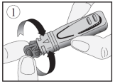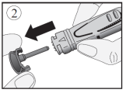

4. Clean the end of the middle finger or ring finger with cotton damped with alcohol.
Rub the chosen finger towards the tip for 10 to 15 seconds to enhance the blood flow.
5. Press platform firmly against the lateral side of the previously cleaned finger, and press the release trigger button③.

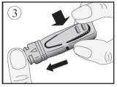

6. The tip will automatically retract into the body of the device.
7. Rub the finger’s end to obtain enough whole blood sample.④.

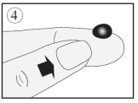

8. Without pressing the bulb, put in contact the plastic pipette with the blood sample⑤. The blood migrates into the pipette through capillarity to the line indicated on the pipette. You may rub again your finger to obtain more blood if the line is not reached. As far as possible, avoid air bubbles.
9. Put the blood collected with the pipette into the sample well of the device, by pressing on the pipette bulb⑥.

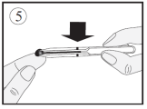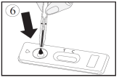

10. Wait 30-40 sec for the blood being totally absorbed into the sample well. Unscrew the blue cap of the diluent dropper bottle (leave the white cap tightly screwed) and add the diluent as follows:
Hold the diluent dropper bottle vertically and slowly add exactly 4 drops in the sample well of the device⑦ with an interval of 2-3 seconds between each drop.

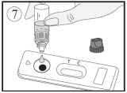

11. Read the result after 10 minutes. Do not interpret after 15 minutes.

RESULTS INTERPRETATION

The intensity and the colour of the lines do not have any importance for the interpretation of the test results.

- Positive result

Two coloured lines appear in the window under the marks T (Test) and C (Control). The intensity of the T line may be clearer than the intensity of the C line. This result means that the prostate specific antigen level is higher than the norm and that you should consult a doctor. | 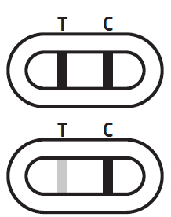
- Negative result

Only one coloured line appears under the mark C (Control). This result means that the prostate specific antigen level is normal. | 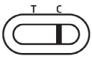
- Invalid result  No line appears or a coloured line appears under the T (Test) mark without any line under the C mark. In this case, it is not possible to interpret the test, which must be considered as invalid. It is recommended to repeat the test with a new PROSTA-Check® and a new blood sample. | 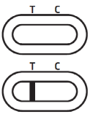

QUESTIONS AND ANSWERS

How does PROSTA-Check® work?
Prostate specific antigen is a protein secreted in semen by the prostate. A part of this protein is found in blood. The blood PSA level allows an estimation of the prostate physiological condition. A value higher than the norm indicates prostate hypertrophy. This hypertrophy may be benign, may be due to prostatitis or may be cancerous in case of adenocarcinoma.
Prostate pathology screening is for men over 50 years and is performed up to 75 years.
The PROSTA-Check® test uses a couple of antibodies that specifically detect PSA by producing a coloured test line under the T mark on the cassette. A control line that captures excess antibodies appears as a coloured line under the C mark on the cassette.
The PROSTA-Check® test allows one to determine a high blood level, above 4 ng/mL (determined against W.H.O.* reference), of prostate specific antigen likely to show benign or malignant prostate hypertrophy.
*World Health Organization

When should this test be performed?
The PROSTA-Check® test can be performed at any time of the day.
However, in the following cases, it is recommended to wait the indicated time before using the test, to avoid false positive results:
 | waiting time
- Cycling/Ergometry | 24 hours
- Ejaculation | 24 hours
- Prostate massage | 2-3 days
- Transrectal ultrasounds | 2-3 days
- Cystoscopy | 1 week
- Prostate transurethral resection / biopsy | 4-6 weeks

Can the results be incorrect?
The results are accurate as long as the instructions are carefully respected.
Nevertheless, the result can be incorrect if the PROSTA-Check® test gets wet before performing the test or if the quantity of whole blood in the sample well is not correct.
The plastic pipette provided in the box makes sure the collected blood volume is correct.

How to interpret the test if the colour and the intensity of the lines are different?
The colour and intensity of the lines have no importance for result interpretation. The lines should only be homogeneous and complete.
The test should be considered as positive regardless of the colour intensity of the test line (T), even weak.

What is the line that appears under the C (Control) mark for?
When this line appears, it only means that the test has been performed well.

If I read the result after 15 minutes, will the result be reliable?
No. The test should be read within 10 minutes after adding the diluent. The results are reliable up to 15 minutes.

What do I have to do if the result is positive?
If the result is positive, it means that the PSA level present in your blood is higher than the norm (4 ng/mL) and that you should consult a doctor to show him the test results. Then, the doctor will decide what you have to do.

What do I have to do if the result is negative?
If the result is negative, it means that the PSA level in your blood is below 4 ng/mL. For patients aged between 50 and 75 years or having relatives suffering from prostate cancer, it is recommended to perform a test regularly.

What is the accuracy of PROSTA-Check®?
The PROSTA-Check® test is accurate and has been used for more than 10 years by professionals (hospitals, laboratories) in the field. Evaluation reports show an overall agreement higher than 87% [81.82 - 92.33**] with referenced methods. Although this test is reliable, false positive or false negative results could be obtained.
**CI 95%: 95% Confidence Interval

Information on prostate cancer and related diseases
Web resource: https://www.cancer.gov/types/prostate/psa-fact-sheet (2018).
Web resource: http://www.cancernetwork.com/oncology-journal/age-specific-reference-ranges-psa-detection-prostate-cancer (2018).

Sterile lancet:  

 Owen Mumford Ltd
Brook Hill, Woodstock, Oxfordshire OX020 1TU (UK)

 GERMANY

Owen Mumford GmbH, Alte Häge 1, 63762 Großostheim, Germany

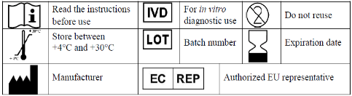

Rue de l’Expansion - ZAT du Londeau - Cerisé
BP 181 - 61006 ALENCON Cedex (France)



CHANGES DESCRIPTION
Changes type :

- N/A Not Applicable (creation)
- Technical change Addition, revision and/or removal of information related to the product.
- Administrative Implementation of non-technical changes noticeable to the end-user.

Changes type | Changes description
Administrative | EC REP for Owen Mumford

Note: Minor typographical, grammar, spelling and formatting changes are not reported in the change details.

PROSTA-Check® Ref. 8084
MD-080020 m 13 c gb – Revised 2021/05
PSAWMCOT600210

